Wentworth Institute of Technology

School of Computing and Data Science

COMP 2650 - Databases

Restaurant Name – Little Eataly

By Jadon Watson and Fabio Tran

Instructor: Nguyen Thai

Date of Submission: April 11, 2022

**Project Topic: Little Eataly**

The type of food we will be serving at the restaurant is traditional Italian food which will be serving lunch and dinner. A feature of the restaurant is unlimited breadsticks as appetizers. Some services include a sit-down bar that offers alcoholic drinks and an outdoor dining option. Customers can reserve seating ahead of time by notifying the restaurant ahead of time. Each menu has a QR code to access an online menu. They can also order food for takeout or delivery. Payment options include cash, card, and electronic pay (Apple Pay, Samsung Pay). The restaurant will also offer gift cards for customers to purchase.

**Business Statement**

Little Eataly is a small business with four locations with the goal of properly representing the food's country of origin (Italy). These foods are a variety of different salads, pasta dishes, subs, and specialty desserts, appetizers that are American and Italian based respectfully (for example mac & cheese bites and homemade meatballs). The pasta will have a variety of choices for sauces, meats, vegetables, and noodles. Salads will have different choices for toppings and dressings. Subs can also be customized with choices of meat, cheese, sauce, toppings, and whether it is toasted. There are many types of Italian appetizers at Little Eataly such as bruschetta. Deserts will have different sizes, flavors, and toppings. Along with food, there are also choices for drinks. Non-alcoholic drink options are water, soda, and juice. Alcoholic drink options are different brands of wines. Since fired food is cooked at the restaurant there need to be industrial grade fryers. Large kitchen stove and oven to cook the meats and vegetables. The restaurant makes fresh pasta by hand. Equipment to prepare food include spatulas, knives, cooking spoon, sauce spoons, cutting boards. The restaurant has industrial-grade freezers and refrigerators to store ingredients. All of the equipment is owned not rented. The restaurant employs both part-time and full-time employees, with a one-year lease. The restaurant allows cashless payment via apple pay, google pay, and order online via Doordash. Restaurant is very modernized and allows online reservations and takeout with meal carry out providers (example Doordash). The restaurant requests that the customer tell the chef of any dietary restrictions so their food can be prepared accordingly.

An important component of any business operation is being able to track operating costs and identify costs that may be rising in the future. For Little Eataly, the company owns four locations spread across the Greater Boston region which are in the cities of Boston, Brookline, Cambridge, and Everett. Calculating rent expenses won’t be necessary because the company owns each restaurant building. However, the company did take mortgages to open up each site. They borrowed one million dollars per location at a fixed 3% interest rate. The company is paying it back for over 30 years. This roughly equates to a $4,200 monthly payment to the lender that must be accounted for in tracking overall costs. Each store location is next to a shopping center so there are public parking lots available as well as street parking. Therefore parking should not be an issue for customers. The company wants to source its inventory locally rather than internationally. They achieve this by using the United States Department of Agriculture's list of certified vendors to get their food and ingredients. Depending on the type of food, delivery directly to the restaurant will be made accordingly. For example, bread might be delivered daily while meat may be every few days. While buying locally is usually more expensive, the restaurant can work with multiple suppliers to get competitive prices for their inventory. About 30% of the restaurants profits will go towards buying more food for their restaurant.. All of the ingredients will be sourced locally so political conflicts are not something to worry about unless there are internal conflicts within the United States. In addition, dealing with multiple suppliers will protect the business if any single supplier breaks down. In terms of other supplies such as kitchenware, the company will use RestaurantSupply.com, which is an online supplier that offers a variety of items that are commercial standard. With regards to salaries, Little Eataly is a fine dining restaurant so they do need to pay higher salaries to attract skilled and experienced workers such as the case for the head chef position. Even for less skilled positions such as waiter/waitress, higher pay will be needed to attract higher quality employees. All the employees can only work at one Little Eataly restaurant. The employees receive benefits of discounted food/drinks at the restaurant along with retirement savings and paid time off. There are salaried and hourly positions at the restaurant. Each restaurant has one manager and one head chef which are both salaried positions. The salary for the manager is $56,000 and the head chef is $61,000. Every restaurant has about 13-15 hourly employees. There are tipped employees such as waiters and waitress who are paid at $7.15 per hour. Non tipped employees such as dish washers and prep cooks are paid $14.50 per hour. Overall each location is expected to make about $250,000 total revenue annually. The cost of food is about 30%, labor is about 30%, 5% will be dedicated to utility costs, and 10% is dedicated to miscellaneous such as repair, decor, or marketing. In the end the restaurant will take home about 25% net profit which is about $57,500.

Another important component of any business is being able to collect data and information to track important date-to-date operations related to customers. This data is important because analyzing it can help improve business profitability. One aspect that needs to be taken into consideration is what days are better for business. For Little Eataly, the busiest days where the most customers will dine at the restaurant is going to be Friday, Saturday, and Sunday. People tend to opt for fine dining experiences on those days so Little Eataly is weekend-oriented rather than weekday-oriented. Statistics show that restaurants earn 20-25% more on weekends than the average weekday. Even though these days are the busiest, the restaurants is still open on the other weekdays to bring in revenue. The location of all the Little Eataly restaurants are nearby shopping centers/plazas therefore there will be plenty of people walking around the nearby area who can be potential customers. The company does not need to worry about the area being too quiet as the other nearby businesses will help drive traffic to the area. With regards to seasons, Little Eataly is not a seasonal business. This means that for the most part the same menu will be served year-round. The only exception is a few special items that might be available or not available depending on the time of the year. Studies shows that 43% of consumers say that menu specialties are important and 23% are willing to pay more for said items which only increases profits for Little Eataly. It is also important to access the impact of holidays on the business is also important. During some holidays, the business performs a lot worse than average but during other holidays, the restaurants will be busier. Holidays that result in fewer customers for example are Thanksgiving due to the fact that more people are likely to spend time at home with their families. An example of a holiday that results in increased traffic to the Little Eataly restaurants is Mother’s Day where people are more likely to take their mother out for fine dining. Research shows that Mother’s Day increased traffic to dine in restaurants by almost 35%. In addition, the weather also plays a role in the number of customers coming to the business. During the summer, people are more likely to go out and dine at restaurants in the process than in the winter months. Therefore, Little Eataly has more customers when the weather is warmer.

Recognizing what days and times of the year are the busiest for the restaurants is important but also analyzing hours of operation on a daily basis is just as crucial to the success of the business. Understanding relevant operation information will improve business profitability and competitiveness in the industry. The Little Eataly restaurants is open from 11 am to 11 pm. Lunch is served from opening until 4 pm which at that point dinner service begins. Compared to competitors, most fine dining restaurants are opening around noontime and close just before midnight. So in this case, Little Eataly is operating at similar hours to its competitors. In terms of peak hours, the business will experience peak hours anywhere from 6 pm to 9 pm which is the case for most if not all fine dining restaurants. Being open till 11 pm will allow the company to effectively capture the evening rush along with follow-up customers till closing. The Greater Boston area has a lot of Italian restaurants so keeping track and keeping up with competitors will be a priority. To make the business more competitive, Little Eataly can offer deals and incentives to increase revenue. Most people dine at restaurants at night making lunchtime a lot less profitable. Depending on the menu item, the prices can be lowered at lunchtime compared to their dinner time price to encourage more customers to come to the restaurants earlier in the day. The prices of food at Little Eataly have to be comparable to other fine dining restaurants in the vicinity. If it is too cheap, the business will not be profitable. If it is too high, not enough customers will be able to dine there. Therefore the prices at Little Eataly should be compared to industry standards and then compared to similar local restaurants to determine a competitive and fair price. Another technique Little Eataly can incorporate is a loyalty program. These programs are shown to have multiple benefits such as increase the amount of returning customers and increase the amount they spent while at the restaurant. In addition, these customers are more likely to refer new customers which increases overall profitability. To provide a unique experience at Little Eataly, the decor will have to be elegant and have an Italian essence to it to give the building an authentic feel. Decorating the restaurant with paintings or other miscellaneous items from Italy can contribute to the dining experience and make the business stand out from competitors. In addition to decor, having a variety of dining options has been proven to increase profits up to almost 65% in similar types of dine-in restaurants. For example, incorporating an outdoor patio could potentially be a wise investment to increase profits as many local competitors already have outdoor dining options.

**Data Modeling**

**Entities:**

Little Eataly

Little Eataly ID

Address

Phone Number

Mortgage

Parking Space?

Dining Options

No Tables

Customer Capacity

Employee

Employee ID

Name

Phone Number

Position

Salary

Hourly Wage

Hours Worked

Benefits

Customer

Customer Number

Name

Phone Number

Table Number

Member?

Rewards Program

Rewards Program ID

Coupons

Discounts

Supplier

Supplier ID

Name

Address

Phone Number

Order

Order ID

Items

Pasta

Pasta ID

Sauces

Meats

Vegetables

Special Ingredients

Noodle Type

Price

Salad

Salad ID

Vegetables

Toppings

Dressings

Price

Sandwich

Sandwich ID

Meats

Cheeses

Sauces

Toppings

Toasted Level

Price

Appetizer

Appetizer ID

Name

Type

Price

Desert

Desert ID  
Size

Flavors

Toppings

Price

Non-Alcoholic Drink

Non-Alcoholic Drink ID

Type

Brand

Price

Alcoholic Drink

Alcoholic Drink ID

Wine Type

Brand

Price

Equipment

Equipment ID

Equipment Types

Quantity

Maintenance Cost

Owned?

Renovation

Renovation ID

Construction Types

Cost

Expense

Expense ID  
Food

Liquor

Labor

Electricity

Water

Internet

Phone

Insurance

Mortgage

Equipment

Marketing

Revenue

Revenue ID

Operation Revenue

**Relationships:**

* Little Eataly has at least one supplier and a supplier may provide for many Little Eataly.
* Little Eataly has many employees and an employee works for only one Little Eataly.
* Little Eataly may have many customers and a customer may go to many Little Eataly.
* A customer may belong to a rewards program and a rewards program may have many customers.
* A customer has at least one order and an order is made by one customer.
* Little Eataly may have many renovations and a renovation may happen at many Little Eataly.
* An order has at least one salad, pasta, subs, appetizer, desserts, alcoholic drinks, or non-alcoholic drinks. Salad, pasta, subs, appetizer, deserts, alcoholic drinks, or non-alcoholic drink may be in many orders.
* Little Eataly serves many types of salad, pasta, subs, appetizer, desserts, alcoholic drinks, or non-alcoholic drinks. A salad, pasta, subs, appetizer, desserts, alcoholic drinks, or non-alcoholic drinks may not be served at every Little Eataly.
* Little Eataly has many equipment and an equipment is at only one Little Eataly.
* Little Eataly has many revenues and a revenue is for only one Little Eataly.
* Little Eataly has many expenses and an expense is for only one Little Eataly.

**ERD:**

**EERD:**

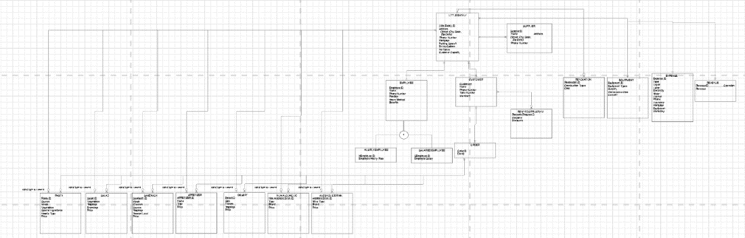

**Link to Full Diagram:** [**lucid.app**](https://lucid.app/lucidchart/e01c3928-6801-4dd0-8876-f3856534cd1a/edit?viewport_loc=-6410%2C-1080%2C8029%2C3089%2C0_0&invitationId=inv_bec3283f-92c3-4196-b290-c04b99de72f8)

**Database Design**

**Relational Data Model (Third Normal Form):**

**Database Implementation**

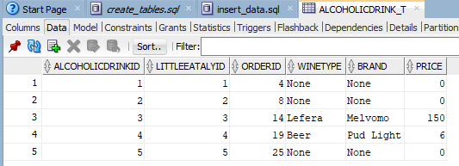

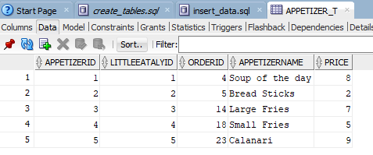

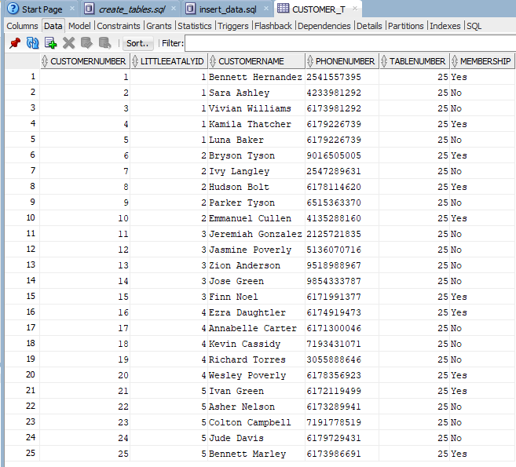

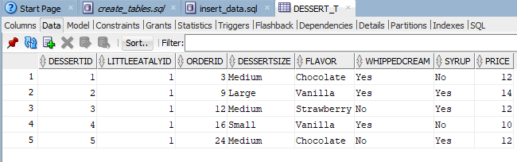

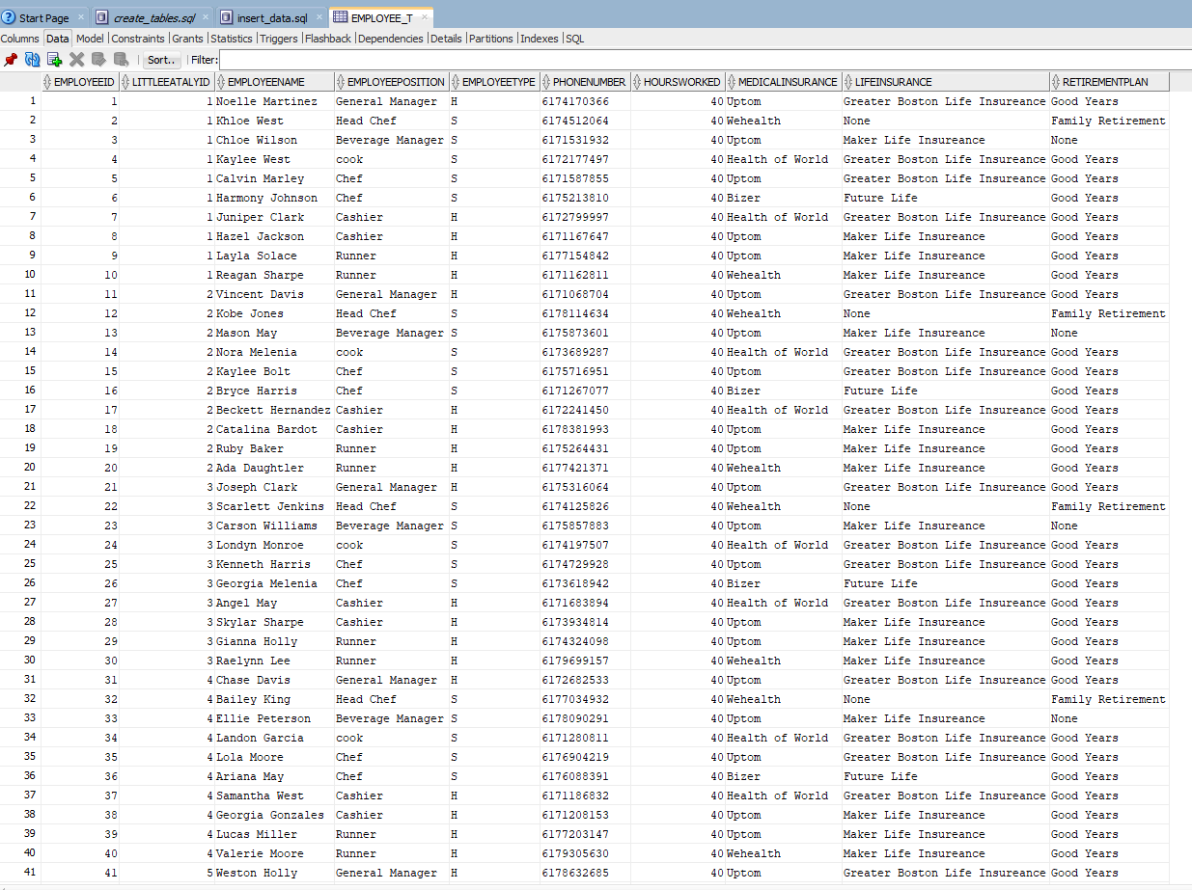

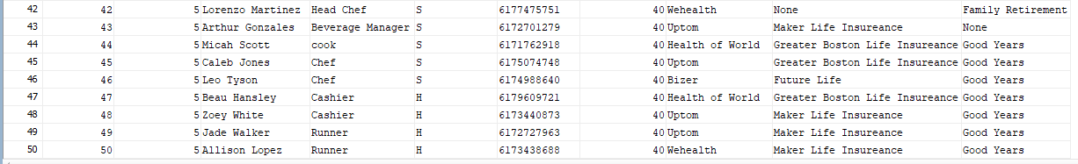

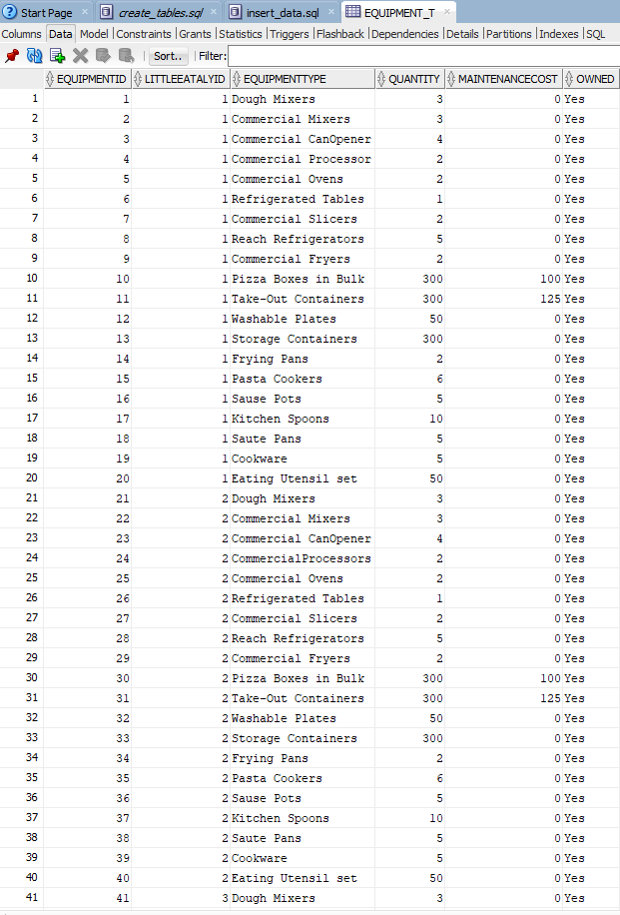

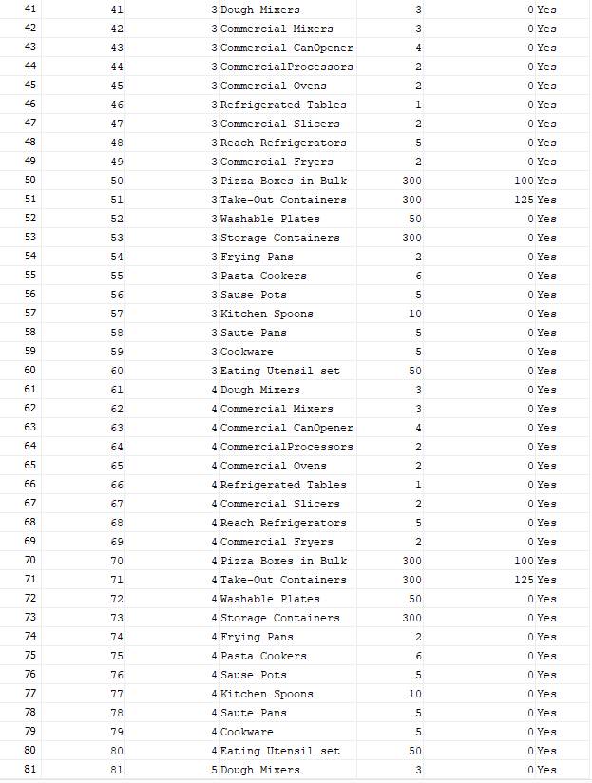

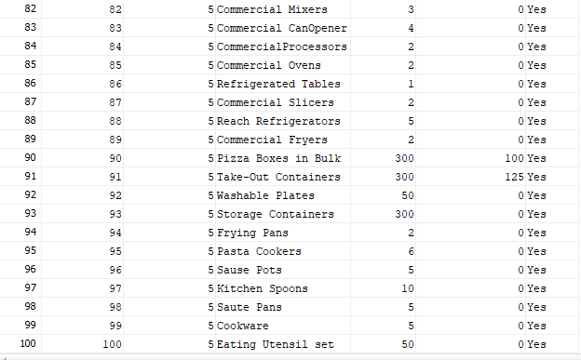

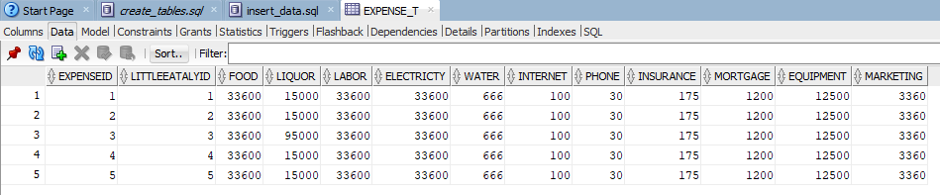

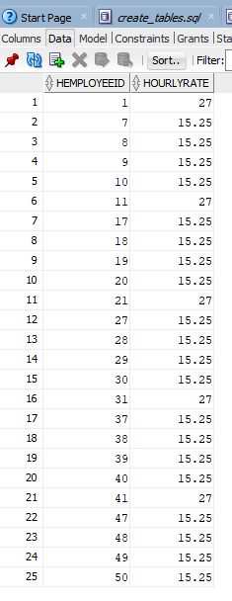

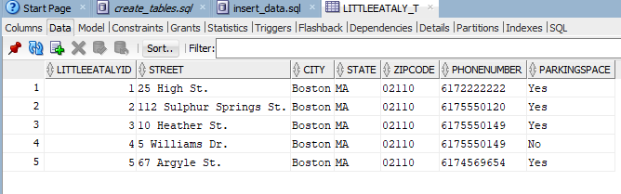

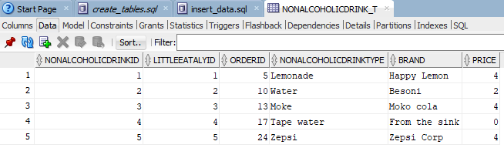

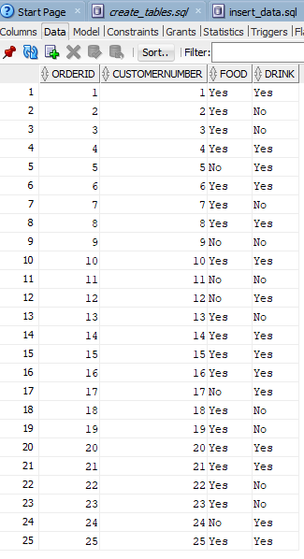

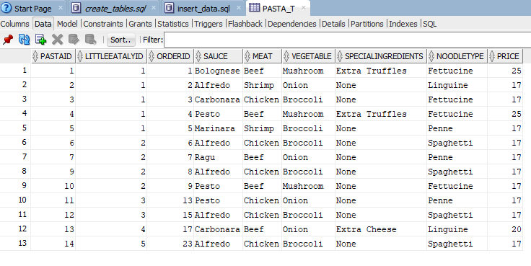

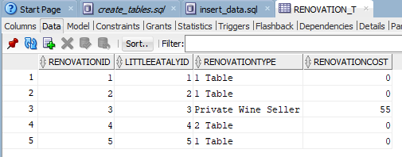

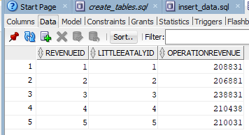

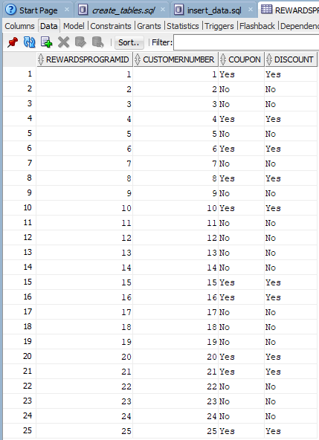

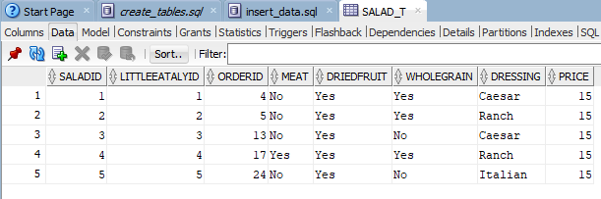

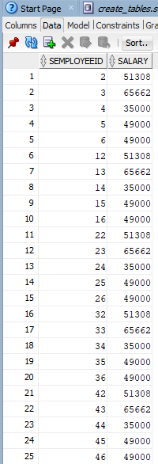

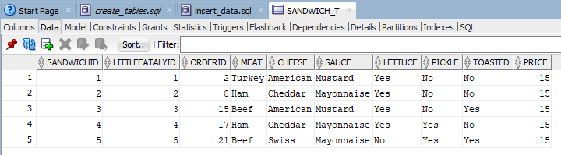

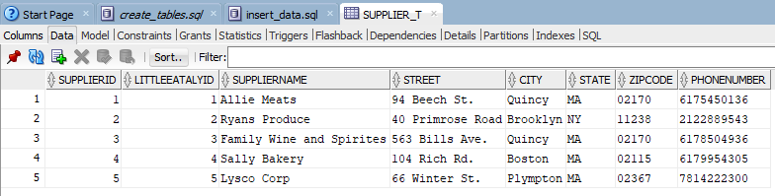

Wentworth Institute of Technology

School of Computing and Data Science

COMP 2650 - Databases

Restaurant Name – Little Eataly

Project Report

By Jadon Watson and Fabio Tran

Instructor: Nguyen Thai

Date of Submission: April 11, 2022

**Project Report**

For this project, the problem we are trying to solve is how to build an effective database to improve a business. In this situation, we are hired to support the restaurant company, Little Eataly, which serves Italian food and owns many restaurant locations in the city of Boston. Because of the many components of its business, Little Eataly needs a database to support its operations and increase its profitability. The design of the database should have the objective of improving current business performance. It should also be well structured and easy to use for the company workers. To support the business, we must understand the business and consider all its components. Most importantly, we need to track expenses and revenues in the database to help the business analyze the profitability of their operations.

Before developing the physical database, it is important to learn and understand how the business operates and its specific rules. Little Eataly is based around Italian cuisine. The food options featured on their menu are salads, pasta, sandwiches, desserts, and appetizers. For each food option, there are a variety of choices for customizations such as sauces, meats, vegetables, toppings, etc. Along with food, there are also choices for drinks. Non-alcoholic drink options are water, soda, and juice. Alcoholic drink options are different brands of wines. All of the food requires various industrial-grade equipment to cook and prepare. When we create the database and track expenses, it is important to cover them because a large percentage of the company’s profits get reinvested into food and equipment.

Along with those, another important component is rent and mortgage. For Little Eataly, the company owns five locations in Boston which each one having expenses for the operating at the property. Calculating rent expenses won’t be necessary because the company owns each restaurant building. However, the company did take mortgages to open up each site that must be accounted for in tracking overall costs.

Another important component to track in expenses is salary and wages since they hire many employers to help run their restaurants. There are salaried and hourly positions at the restaurant. Each restaurant has one manager and one head chef which are both salaried positions. Every restaurant has many hourly employees to fill various roles such as host and server. The cost of labor can take up a large percentage of the business profits so it is important to track when we implement our database.

Furthermore, another factor that can contribute to Little Eataly’s expenses and revenue is investments into renovations. Decorating the restaurant with paintings or other miscellaneous items from Italy can contribute to the dining experience and make the business stand out from competitors. In addition to decor, having a variety of dining options has been proven to increase profits up to almost 65% in similar types of dine-in restaurants. Since spending on renovations can lead to increase revenue, it is important to incorporate in the database implementation so the restaurant owners can analyze to see if there return on investment is worth it.

Lastly, a component of Little Eataly’s business that is important to consider is their membership program and discounts. These programs are shown to have multiple benefits such as increase the amount of returning customers and increase the amount they spent while at the restaurant. In addition, these customers are more likely to refer new customers which increases overall profitability. Therefore it is important to track in the database how many customers are members of the restaurants program. In addition deals and incentives also increase revenue. Most people dine at restaurants at night making lunchtime a lot less profitable. Depending on the menu item, the prices can be lowered at lunchtime compared to their dinner time price to encourage more customers to come to the restaurants earlier in the day. Tracking the prices of items served at Little Eataly in the database can be useful when it comes to the analysis of the business operation.

Once we learned and understood the business we can develop a business data model also known as a conceptional data model. The goal of this is to get a general idea of the components or entities in a business and their relationship with one another. Essentially, the logical model represents business information and its rules. To achieve this step in the project, we created an entity-relationship diagram (ERD) and an enhanced entity-relationship diagram (EERD) to conceptualize Little Eataly’s business model which is shown below:

ERD:

EERD:

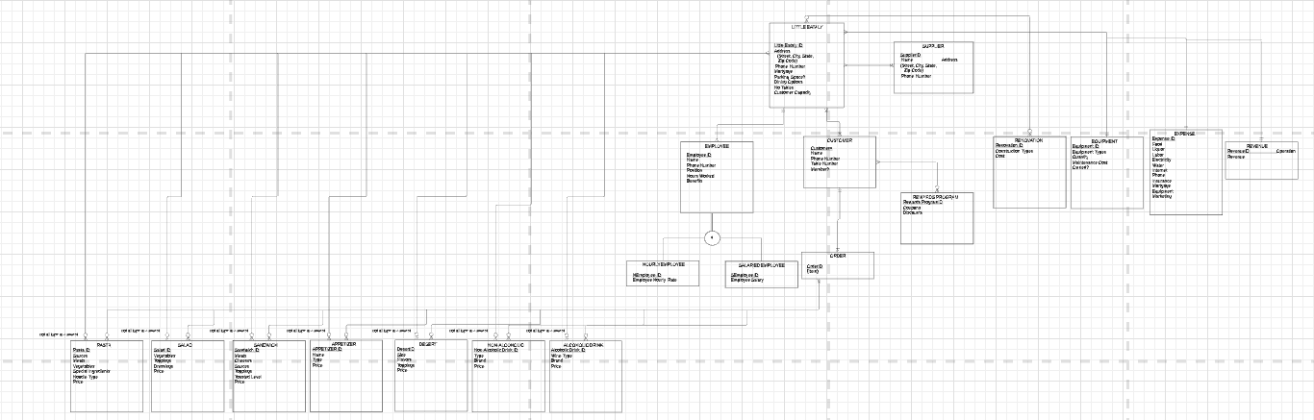

The original ERD diagram models the various entities that are important to the business operations of Little Eataly and that should be tracked in the database. The EERD takes the ERD and adds capabilities of supertype and subtype relationships which we used for the case of the employee's entity. We separated employees into salary and hourly employees since there are workers who are paid either an hourly wage or a yearly salary. This step of the project is crucial as it is the first point of the process where we can visualize the business we are trying to model. Performing this step makes the following steps and eventual database implementation simpler.

The next step after the creation of the business data model is converting it to a logical data model. While the business data model is more general, the logical data model has more details and more closely represents how it will be physically implemented in a database as it describes the data more in-depth. The logical data model we created for Little Eataly, in the form of 3rd normal relations are shown below:

Like the previous steps of the project, this is also extremely crucial as we are representing the business in a model that can be easily translated to the physical database. Important things we must perform in this step are dealing with primary and foreign keys and making sure they are pointing to the proper relations. This process requires a lot of attention but is important in overall database development. Now that we have a logical data model of Little Eataly, we can use that to implement the physical database.

After writing SQL statements to create tables for our database, we also wrote statements to insert instances or data into our database for analytical purposes. The five business analytical points we were focused on are the following: food and drink popularity, employee salary distribution, sale of meals vs drinks, revenue per month, expenses per month. We used query statements to derive information that would help us in our analysis. From the data we received from the query statements, we created graphs in Microsoft Excel to display and support our analysis with helpful visuals. Firstly, the graph for food and drink popularity is shown below:

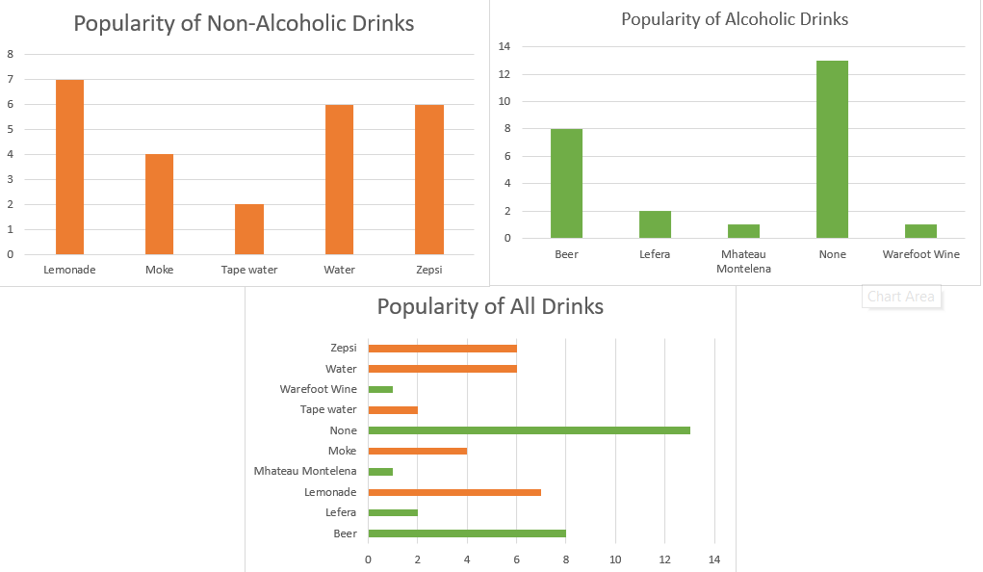

This graph compares the number of times each drink is ordered which can be used to determine the popular drinks at the Little Eataly restaurants. In the graph titled “Popularity of All Drinks,” we can see that most often a customer will not order a drink with their meal. However, if they do decide to order a drink the most popular alcoholic option is beer, and the most popular non-alcoholic option is lemonade. This makes sense as lemonade is a common popular option in restaurants and beer is more affordable than most wines hence why they sell more.

Next, this is the graph for employee salary distribution:

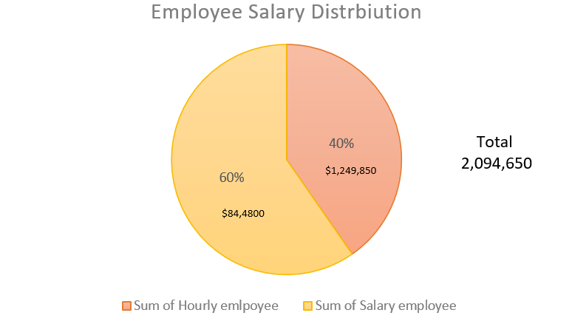

From this graph we can see that out of approximately two million dollars that is allocated to paying company workers, 60% of that will be going to salaried employees and 40% are going to hourly employees. While there are more positions paid hourly such as hosts, waiters, servers, and dishwasher, their hourly wage is comparatively low compared to the high salary given to the chef and manager positions. The high salaries given to the top positions at Little Eataly cause the distribution to be higher for the salaried employees over hourly employees.

Next, this is the graph we created to compare sales of meals vs drinks:

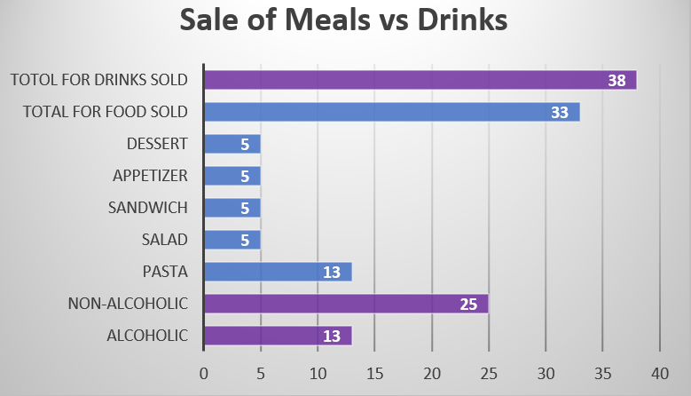

This graph shows us the distribution of sales between individual food and drink categories as well as their total. From this we can see that the number of foods and drinks sold is almost equal. These numbers are similar because people usually buy drinks along with their meal when they eat. Another notable factor to mention is that non-alcoholic drinks sell more than alcoholic drinks. There are multiple reasons that can explain this, being that usually older people over 21 years old can order alcoholic drinks and it is mostly during the evening. On the other hand, non-alcoholic drinks can be ordered by anyone and at any time of the day, which explains their higher sales. Lastly it is important to mention that the graph shows that pasta is the most popular dish. This also makes sense because pasta is primarily the main entrée for people who dine at Italian restaurants such as Little Eataly.

Next, we created a graph to display revenue per month of each of the Little Eataly locations:

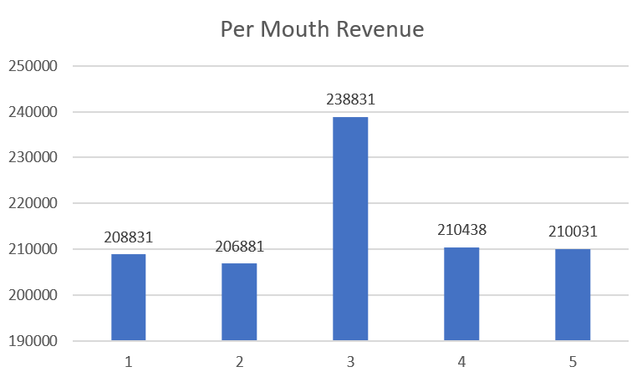

From this graph, we can see that the revenue for each Little Eataly location is similar. This is due to all the restaurants being a part of the Little Eataly franchise, so their operations are run alike one another. In addition, all the restaurants are in Boston, so the market of potential customers is similar for each location. We can see that location three has notably more revenue per month than the other four locations. The other locations can analyze that location to potentially help boost their own restaurant to be more profitable. Since the revenue for each location is approximately $200,000 per month, each location must spend under $200,000 in expense per month if they want to have a profitable and sustainable business.

Lastly, we created a graph to show expenses per month for each Little Eataly location:

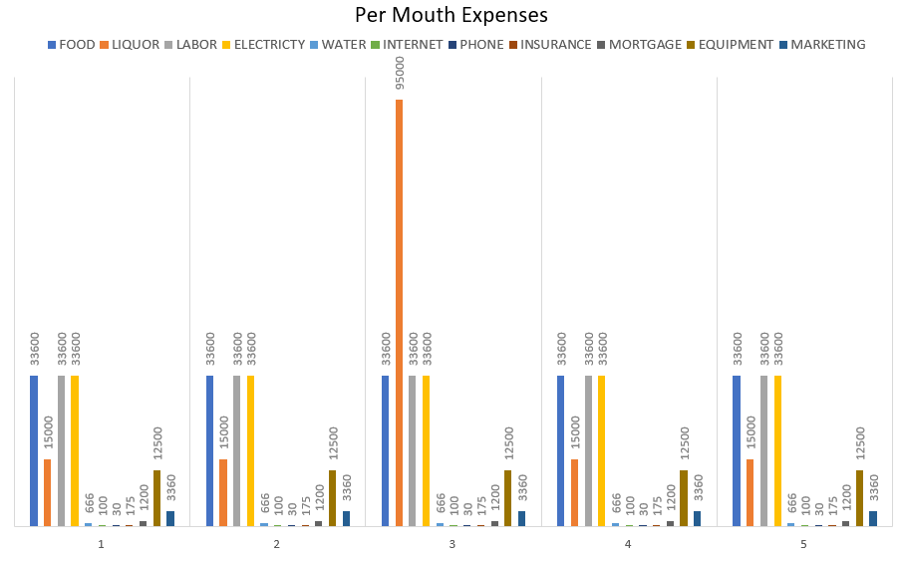

For each location, the amount of money allocated to food, liquor, labor, electricity, water, internet, phone, insurance, mortgage, equipment, and marketing is remarkably similar. This makes sense as all the locations are a part of the Little Eataly company and will be operating similarly to each other. The only outlier is location 3 that spends significantly more on liquor in their expenses. Going back to the previous graph showing per month revenue, location 3’s higher revenue can be explained by higher investment and sales of liquor. Using the Per Month Revenue and Per Month Expenses graphs, we total the expenses for all locations combined to be $749,155 and the total revenue is $1,075,012. Calculating the difference leaves the Little Eataly company with a profit of $325,857. Dividing the total by the number of locations yields an average profit of $65,171 for a single Little Eataly location. This is a positive sign for the business operations as they are making more than they are spending in the company.

After going through the process of database development from the ground up there are many things we learned. It is to understand the business and to be diligent when creating models to represent it. If you are not careful at the designing stage, it will only complicate the implementation phase and can lead to potentially problematic bugs and inaccuracy. There are components or ideas that we did not think about in the earlier phases of the project that we realized now are important to consider. For example, when we inserted data in our database to analyze the business operations, our expenses were representative of the monthly average of a general restaurant in Boston while our revenue was based on the spending of just 25 customers. In real life, this would not make sense and in our project, we should have accounted for this to have an accurate and reasonable analysis of expenses vs revenue. In addition, we recommend improvements in our system to keep track of food and drink discounts. Our current database keeps track of the price food and drinks are sold for but does not have any way of tracking if the item was discounted and if so by how much. It is important for Little Eataly to not give too many discounts as they can potentially underprice their food and drinks, but at the same time allowing some discounts can lead to overall increase sales. Little Eataly can use this data collected in analyzing the optimum number of discounts to occur to maximize profits. Implementing these recommendations will lead to a more useful database and stronger business operations for Little Eataly.